EXPERIMENT 10 FIBONACCI SEARCH

A IM: To find the running time of Fibonacci search algorithm using Z transform

Mathematical background:

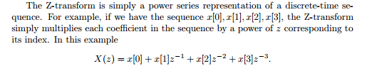

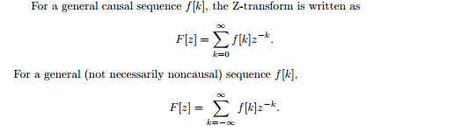



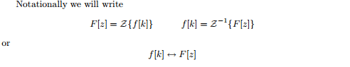

Fibonacci Numbers are recursively defined as F(n) = F(n-1) + F(n-2), F(0) = 0, F(1) = 1. First few Fibinacci Numbers are 0, 1, 1, 2, 3, 5, 8, 13, 21, 34, 55, 89, 144, …

**Algorithm:**  
Let the searched element be x.

The idea it to first find the smallest Fibonacci number that is greater than or equal to length of given array. Let the found fibonacci number be fib (m’th fibonacci number). We use (m-2)’th Fibonacci number as index (If it is a valid index). Let (m-2)’th Fibonacci Number be i, we compare arr[i] with x, if x is same, we return i. Else if x is greater, we recur for subarray after i, else we recur for subarray before i.

Below is complete algorithm  
Let arr[0..n-1] be th input array and element to be searched be x.

1. Find the smallest Fibonacci Number greater than or equal n. Let this number be fibM [m’th Fibonacci Number]. Let the two Fibonacci numbers preceding it be fibMm1 [(m-1)’th Fibonacci Number and fibMm2 [(m-2)’th Fibonacci Number./li>
2. While the array has elements to be inspected:
   1. Compare x with the last element of the range covered by fibMm2
   2. **If** x matches, return index
   3. **Else If** x is less than the element, move the three Fibonacci variables two Fibonacci down, indicating elimination of approximately rear two-third of the remaining array.
   4. **Else** x is greater than the element, move the three Fibonacci variables one Fibonacci down. Reset offset to index. Together these indicate elimination of approximately front one-third of the remaining array.
3. Since there might be a single element remaining for comparison, check if fibMm1 is 1. If Yes, compare x with that remaining element. If match, return index.

MATLAB CODE:

clc

clear all

syms z Y n positive

LHS=ztrans(sym('y(n+2)')-sym('y(n+1)')-sym('y(n)'),n,z);

RHS=ztrans(0,n,z)

newLHS=subs(LHS,{'ztrans(y(n),n,z)','y(0)','y(1)'},{Y,0,1});

Y=solve(newLHS-RHS,Y);

y=iztrans(Y,z,n)

OUTPUT:

ENGINEERING INTERPRETATION:

Difference equation is an important concept to find running time of many algorithms.Apart from this it is also used to find memory size needed to store arrays .It is also used in the field of machine learning and data science. Differential equation is definitely an important part in games.Apart from jumping and moving,it is also used to do many other movements like shooting a gun(where bullet position is calculated on the basis of differential equations),driving a car(car’s position based on acceleration and deceleration is calculated by differential equations),running,etc.In each and very case,there are different differential equations and different constraints, and in each and every case the final output is finding the new position of the object.One can also use them for complex movements like fighting etc. where a lot of differential equations are required to be solved simultaneously.Wherever there is physics of motion involved,there is differential equation .